Greek Week

Big Idea
- The people and cultures of Ancient Greece made invaluable contributions to modern day architecture, arts, math, science, theater, religion and more!
Essential Questions
- What kinds of architecture, sculpture, literature and theater are characteristically “Greek”?
- What are the major math and science contributions made by ancient Greeks to modern day?
- Why is learning about Ancient Greece important?
Studio Habits of Mind | Operation in lesson
- Engage & Persist | - Students engage all 5 days of the week through intensive hands on activities related to Greece- most of which cannot be completed quickly or with little effort.
- Develop Craft | - In sculpting clay columns and other activities, students will need to work carefully and thoughtfully with new materials to complete the exercise well.
- Understand Our Worlds | - The week includes a great deal of reflection about what contributions of ancient Greece we see and use every day.
CCSS
6.3: Describe the rise; the political, technological, and cultural achievements; and the decline of ancient civilizations in Europe, Asia, and Africa prior to the Roman Empire.
National Arts Standards
VA:Re.7.1.6a: Identify and interpret works of art or design that reveal how people live around the world and what they value.
VA:Cn11.1.6a: Analyze how art reflects changing times, traditions, resources, and cultural uses.

Session 1: Greek Math and Science

Learning Goal |  | Assessment
- I can name at least two math and science contributions. |  | - Students participate in math and science activities and can recreate relevant inventions.
Materials | Preparation
- Intro PPT  - Recycled materials for pulley/lever stations  - Sun dial materials (paper plates, straws, rulers, pencils) | - Load PPT  - Gather sundial materials  - Prep lever and pulley stations
Vocabulary
- Sundial | - Lever
- Pulley
Procedures
- Pre-teach overview of cultural achievements of Greece.
- See PPT: Overview of 3 main contributors.
- Make sundial (see directions—attached).
- Split class into two groups – levers and pulleys. Teams make levers and pulleys from various materials (rulers, paper cups, beans, Swedish fish, tape, and extra materials like pipe cleaners, bits of wood, string) etc.
- Share out discoveries and successes at end of class.

Session 2: Ancient Greek Sculpture

Learning Goal |  | Assessment
- I can seek out and describe the major types of Greek pottery and associated designs. |  | - Students can complete matching came with accuracy.
Materials | Preparation
- PPT  - Matching game  - Glue sticks, scissors | - Load PPT  - Make copies of matching game
Vocabulary
- Red Figure, Black Figure, Corinthian, Geometric
- Amphora, lekythos, etc.
Procedures
See PPT:
- Review major types of Greek sculpture on Google Cultural Institute: Classical and Hellenistic. (Korous Discobolos)
- Quick check for understanding: Describe classical on one side of notecard and Hellenistic on other. Turn in.
- Review major types of pottery: Geometric, Corinthian, Red Figure & Black Figure and types of vessels (see attached documents).
- Introduce activity: · In pairs or trios, and by using the projected information, match the unlabeled pottery descriptions with their description to the best of your ability.
- Teacher checks work when students finish.
- When you have been checked off, you will choose from the vase a description of a vessel. You will need to collect materials of your choice to draw your vessel. Each individual will make a drawing. You will have the remainder of the block to finish your vessel. Use your reference images to help guide you. Use your imagination
- If students are familiar with printmaking, it is a fun extension to forego the drawings for making prints of vessels.
- When finished, students share drawings and descriptions under doc cam. Give feedback to each other!

Session 3: Ancient Greek Religion/Mythology

Learning Goal |  | Assessment
- I can name major Greek Gods and Goddesses and what they are known for. |  | - Students participate in reading plays and working as a team.
Materials | Preparation
- God and goddess name slips (cut up)  - Short plays (2-4, depending on class size). | Load video  Cut up God and Goddess name slips (names from video)  Copies of Greek plays
Vocabulary
- Mythology | - Engage & Persist
- Stretch & Explore
Procedures
- Watch Greek Gods and Goddesses video: https://www.youtube.com/watch?v=eJCm8W5RZes
- Discuss: What names do you recognize? What do gods and goddesses have to do with sculpture we looked at yesterday?
- Game: choose a god or goddess name out of a hat. You have two minutes to come up with a “movement” that describes that god or goddess. All students get in a circle and introduce themselves while making the movement they came up with. Have at least one student try to name everyone before you sit back down.
- Teacher assigns parts in Greek plays. Ideally, each class is split into at least two parts so that there can be actors and an audience.
- Students get into groups and practice reading plays with expression and movement.
- Students discuss the use of props or necessary choreography.
- After a few rounds of practice and feedback from teacher, students perform.
- Audience gives feedback.

Session 4: Ancient Greek Architecture

Learning Goal |  | Assessment
- I can use air clay to develop craft in Greek architecture. |  | - Students sculpt a Greek column that is accurate in style.
Materials | Preparation
- Architecture PPT  - Air dry clay  - Sculpting tools are helpful but not required. (Toothpicks, toothbrushes, wire and various kitchen tools work just as well).  - Wax paper  - Clear table to place columns to dry | - Cut clay into 1 individual chunk per student (or pair, if desired)  - Pre-tear wax paper so each student can have at least one sq ft to work on  - Load PPT
Vocabulary
- Develop Craft
- Ionic, Doric, Corinthian colums
Procedures
- Load PPT: Discuss “Greek” Architecture
- Give suggestions about working with clay. Make the column in pieces- capital, base, shaft). Add décor last. Score (make crosshatched lines) pieces and twist slightly to secure them together.
- Students should make one column or a set of columns.
- End class with a mini gallery walk and share out of what worked well and where there were challenges.

Session 5: Ancient Greek Sports – Olympic Day!

Learning Goal |  | Assessment
- I know how to engage physically with Greek athletics! |  | - Students participate in simulated Olympics and work positively and collaboratively.
Materials | Preparation
- Buckets (2-4) (1-3 gallon)  - Clear 1-2 gallon tubs  - Ping pong balls (6)  - Copies of word scramble  - Tongue twisters (enough for each student)  - Water  - Plastic or metal spoons  - Tape  - Pencils  - Day 5 PPT | - Gather all needed materials  - Make copies of tongue twisters (as needed) and cut up for easy choosing  - Copies of word scramble  - Tape clear jars for water race  - Load PPT
Vocabulary
- Olympics
- Pentathlon
Procedures
- See PPT: Review Greek values of mental and physical fitness: What does that mean to you? Why are both important? If time, make a Venn Diagram to compare ideas related to the two.
Begin Olympics: Inside activities first. Begin with Javelin throw. One team member holds a bucket on their head and stands in a designated area of the room. Other members line up and one by one throw a ping pong ball into the bucket with one hand. The member with the bucket may move but can’t take bucket off head. This is timed. Game ends when each group has made 6 ping pong balls successfully into bucket. Best time wins. Note winners on board (to award a bronze, silver and gold medal at end of day).
2. Word scramble: Create one with vocab words surrounding what we learned this week. The whole group wins if someone from their group finishes first. Wait for two first finishers. While others keep working, reorder winning groups.
3. Tongue Twisters: Pull a Greek myth themed tongue twister from a jar and when teacher says go, say it 3 times fast. Each team member for him or herself. Fastest to say it 3 times correctly wins. This is great for a tie.
4. Outside: Water Race: Fill a bucket with water and a tape a clear bucket to denote where the water must fill to in order to win. Students line up and one by one, dip spoon into water and carry to clear bucket, dump, and return spoon to next student in line. Continue until water is filled to designated line. Teams may compete simultaneously until there is a winner.
- Congratulate Bronze, Silver and Gold Winners!

DAY 1: MATH & SCIENCE

When talking about ancient Greece it only seems right to shed some light on the huge contributions ancient Greeks made to modern day math and science (along with sculpture, architecture, theater, religion, sports and more!)

Largely, these contributions stemmed from a desire to create order out of chaos- remember the reason for mythology- to explain natural phenomena without advanced technology. Oceans, earthquakes, weather… strides in education (college even) in 600 BC, meant new ways to explain things and bring order.

Let’s discuss four main contributors:

(“you-klid”) Euclid: Father of Geometry

- Lived around 300 BC, Greek mathematician, but mysterious- little is known.
- He did however write 13 books about geometry, inventing many of the ways we understand space, time, and shapes.
- He proposed a number of ideas about math, and you’ll get to try out a few of them today.

Here’s the big 5 things:
1. A straight line segment can be drawn joining any two points. (try it)
2. Any straight line segment can be extended indefinitely in a straight line. (try it)
3. Given any straight line segment, a circle can be drawn having the segment as radius and one endpoint as center. (try it)
4. All right angles are congruent. (the same)
5. If two lines are drawn which intersect a third in such a way that the sum of the inner angles on one side is less than two right angles, then the two lines inevitably must intersect each other on that side if extended far enough. This postulate is equivalent to what is known as the parallel postulate.

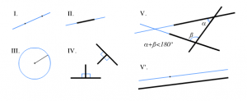

Pythagorus

~500 BC

- Name: Pythagorean theory!
- A squared plus b squared equals c squared!
- Demo on board (or have student do it)
- Also, he believed that you can use pi to calculate the circumference of a circle (demo)

Archimedes

~300 BC
Greek mathematician, physicist, engineer, inventor and astronomer
Calculus, geometry, surface area, volume, and much more!
Contributed to lever and pulley system to move objects
Why are levers and pulleys important?

Sundial

A sundial measures time by using a shadow cast by the position of the sun. As the earth turns on its polar axis, the sun appears to cross the sky from east to west. Both the direction and the height of the sun can be used to measure time. Sundials were used until 1830s!

We don’t know for sure if it was the Babylonians, the Egyptians, the Romans or the Greeks who truly invented the sundial, or if it was a combination. The Greeks, though, developed many of the parts of a sundial. Since Greeks founded geometry, they were well set up to advance the sundial (which relies on exact measurements and angles to be useful).

Essentially, a sundial is a flat or curved surface with a rod sticking out the center. The rod and the 12-noon mark are vertically aligned. The rod is tilted towards the nearest pole (for us, that’s the north pole). If put outside on a sunny day, the sun will cast a shadow to “tell the time.”

Start at 1:30, end at 4:00
https://www.youtube.com/watch?v=Hu3Pb6RNyy4

Make Sundial as a class in part A, then test outside during part B.

Prepare Paper Plate
- Start this project on a sunny day
- Use the pencil to poke a hole through the very center of the paper plate. Write the number 12 on the edge of the plate with a crayon. Using the ruler as a guide, draw a straight line from the number 12 to the hole in the center of the plate.

Take Plate Outside
At noon, take the plate and the straw outside. Put the plate on the ground and poke the straw through the hole. Slant the straw toward the line you drew. Now carefully turn the plate so that the shadow of the straw falls along the line to the number 12.
If you take this home to test it out, you’ll fill in the rest of the numbers on your handmade clock as the shadow moved each hour.

Introduce stations:
- Use materials to make a lever that can weigh out two equal parts of fish (Swedish fish). Take apart when finished for others to use materials?

- Use materials to make a pulley that can move 30 stones (sugar cubes) in 2 minutes.

- Use spiral worksheet to consider what Pythagorean theorem means in the natural world and add to the design.

Students can choose a partner or do stations alone.
Split students in thirds between spiral station and lever and pulley stations.
Switch ever 10 -15 minutes.

Share out discoveries and successes at end of class.

Day 2: Pottery

· Greek sculpture is an art form that developed over the course of more than 1000 years
· It was/is the foundation for not only Roman sculpture, but for western (our) sculpture today
· Lots of human/god sculptures, but there were animal sculptures and natural sculptures as well.
· Two big types: Classical and Hellenistic
Classical Period: ~ 500-200 BC
· Korous and Statuette of Korous (first two images)
· Early sculpture (~500-250 BC): influenced by works of ancient Egyptians- perfection in the human form (though figures appear rigid and unnatural, reflected a body being assembled in pieces like a mannequin)
· This is referred to as kouros or kore- statues that stand straight and tall with feet together and a blank stare
· Things associated with classic art: Rules, conventions, religion, nature (symbols)
Hellenistic Period: ~300 - 50 BC
· Tanagra and Discobolos (third and fourth image)
· Beyond just anatomy: look at the way the body moves, depicts emotions, portrays dramatic features that are filled with happiness, anger, agony, humor
· Not as idealized: What does that mean?
· Discobolos: Discus Thrower: Known for Contrapposto stance: when one leg is extended and the imaginary shift in weight is modeled into the sculpture to convey gravity and enhance realism : This athlete has flexing muscles, concentrated expression, the statue lets us in on the moment just before the string is released from the bow

Another word for pottery: vessel
Pottery important in Greek culture
· Oldest and most diverse representations of cultural beliefs and practices of greeks
· They are durable- holds up over time (become great tools for archeologists and historians) Meant for everyday use even though they are intricate and beautiful pieces of art
Four main styles of Greek vessels:
· Geometric: earliest style, geometric shapes, lines, some animals, simple
· Corinthian: Greece had more contact with east asia, more plants and animals in these vessels than people, lighter backgrounds usually (brown or tan) rather than black or red
· Red figure: drawn red figures and a painted black background- often gods and goddesses
· Black figure: black figures on red background - often gods and goddesses
Four of the many types of vessels:
· Amphora: big, carry water and fish oil, hourglass shape, two top handles
· Lekythos: small oil jar, small curved handle, small top
· Krater: for mixing- wide mouth top, low handles
· Kylix: drinking cup- very wide mouth top
Discuss: Do you see any similarities between the types of vessels (pottery) shown here and what you use today to hold oil, to mix things, to drink from?
Styles of pottery:
Geometric: geometric shapes, lines, animals
Corinthian: more plants and animals than people
Red figure: drawn red figures on a painted black background
Black figure: drawn black figures on a red background
Types of pottery:
Amphora: tall, large, to carry water and fish oil, hourglass shape, two top handles
Lekythos: small oil jar, small curved handle, small top
Krater: for mixing- wide mouth top, low handles
Kylix: drinking cup- very wide mouth top

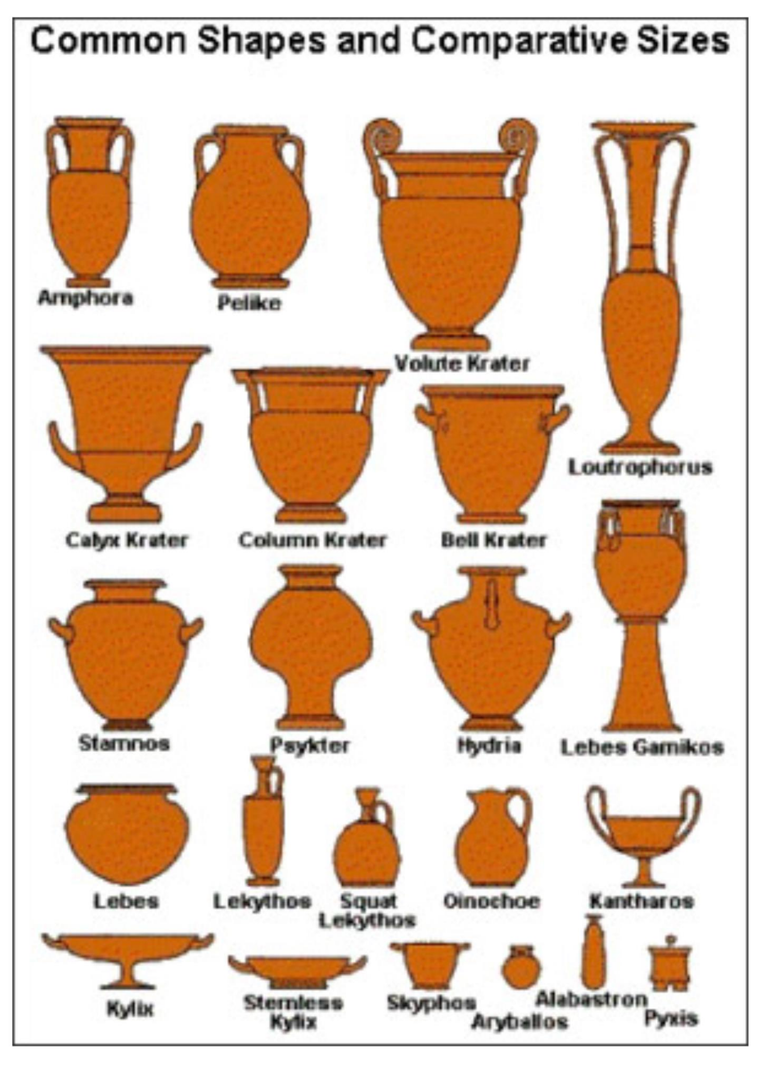

Geometric Amphora

Corinthian Lekythos

Red figure Krater

Red figure Amphora

Black figure Amphora

Red figure Kylix

Corinthian Krater

Black figure Krater

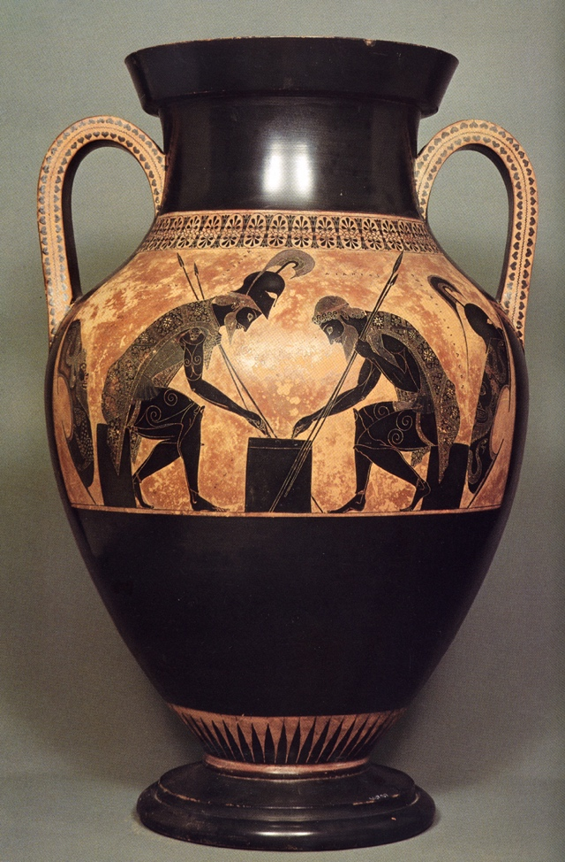
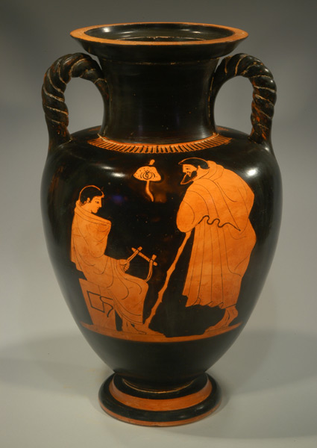

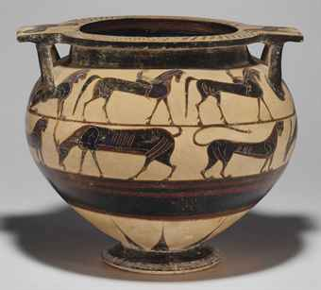

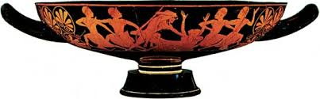

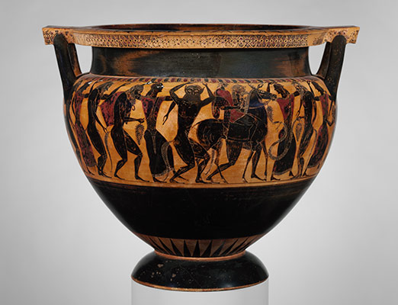
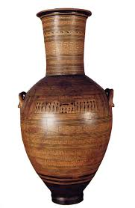

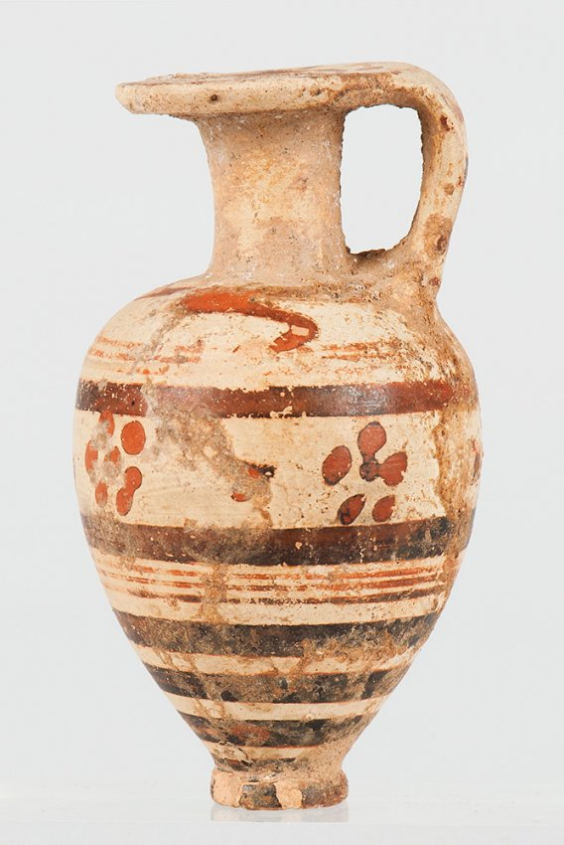

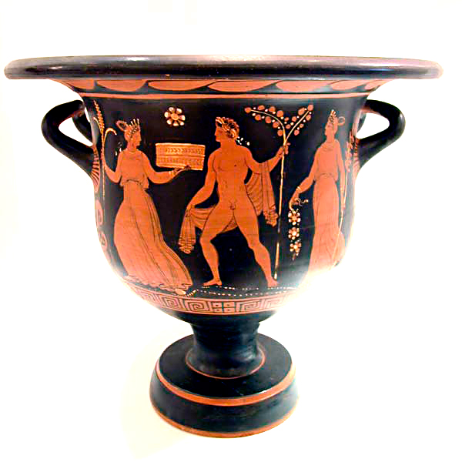

Top 14 Gods and Goddesses of Ancient Greece:

Hermes – messenger
Hephaestus – fire
Ares -- war
Cronos – king
Apollo – sun and light, healing
Dionysus – bad judgement/drunkenness
Prometheus – creator of mankind
Poseidon – the oceans
Hades – underworld/darkness
Zeus – thunder and lightening
Aphrodite – love and beauty
Venus -- victory
Hestia – home/hearth
Athena – arts and skill
Artemis – huntress

