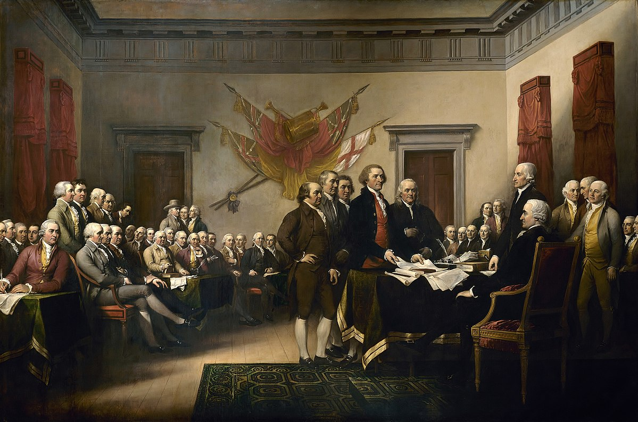

*Signing of the Declaration of Independence,* Oil on Canvas by Paul Trumbull, 1819